Day -2
Power supply systems : Basic of SMPS and UPS System

1.List 3 real-world devices in your home or college that use SMPS (Switched Mode Power Supply) and 2 devices that use UPS (Uninterruptible Power Supply), explaining in one line why each device needs that type of power supply.
What is SMPS?
SMPS (Switched Mode Power Supply) is a power supply that converts the electrical power from the mains into the required DC voltages needed by electronic components.
For example, a desktop PC receives 230 V AC from the wall socket, but its motherboard, hard disk, SSD, fans, etc. need lower DC voltages such as 12 V, 5 V and 3.3 V. The SMPS performs this conversion.
3 real-world devices that use SMPS
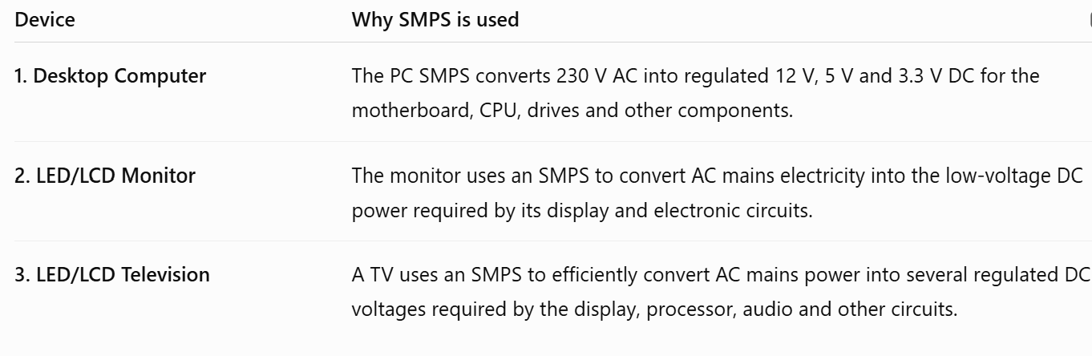
Easy way to remember
Wall socket → AC → SMPS → Required DC voltage → Electronic components

Devices Using UPS
What is UPS?
UPS (Uninterruptible Power Supply) is a backup power system. It provides power to a device when the main electricity supply fails or becomes unstable.
A UPS normally contains:
- Battery
- Charger
- Inverter
- Control/protection circuits
When electricity is available, the UPS charges its battery. If the electricity goes off, the UPS supplies power from the battery, allowing the connected equipment to continue operating for some time.
Important: UPS and SMPS are not the same thing. An SMPS converts and regulates power for a device, while a UPS provides backup power during a power failure.
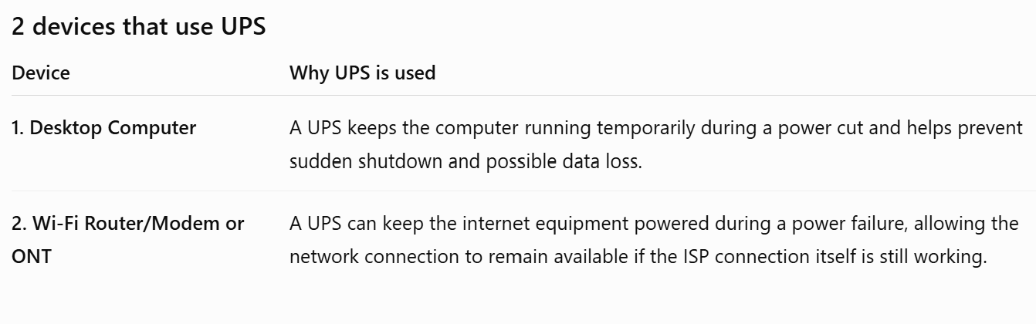
Important distinction
A desktop PC may have both an SMPS and a UPS:
Wall socket → UPS → PC SMPS → Motherboard/CPU/Storage
The UPS provides backup power, while the PC's SMPS converts that power into the DC voltages required by the computer.

2.Draw and label a diagram showing the main internal components of a typical SMPS unit found in a desktop PC, including AC input, rectifier, transformer, and DC output sections.
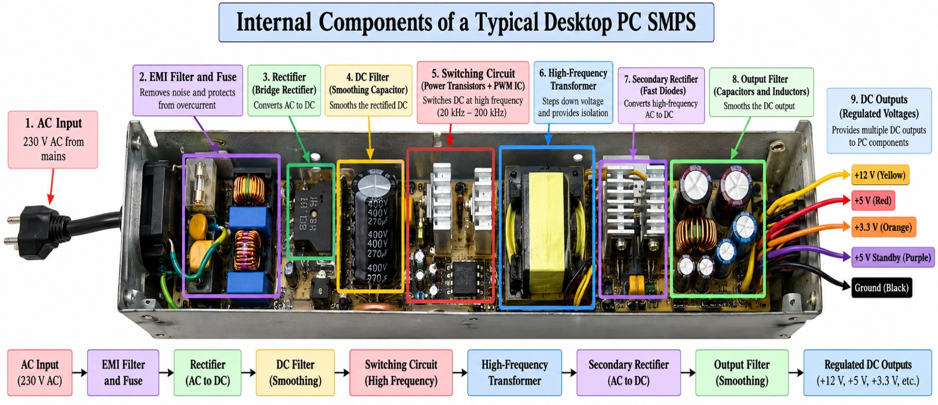
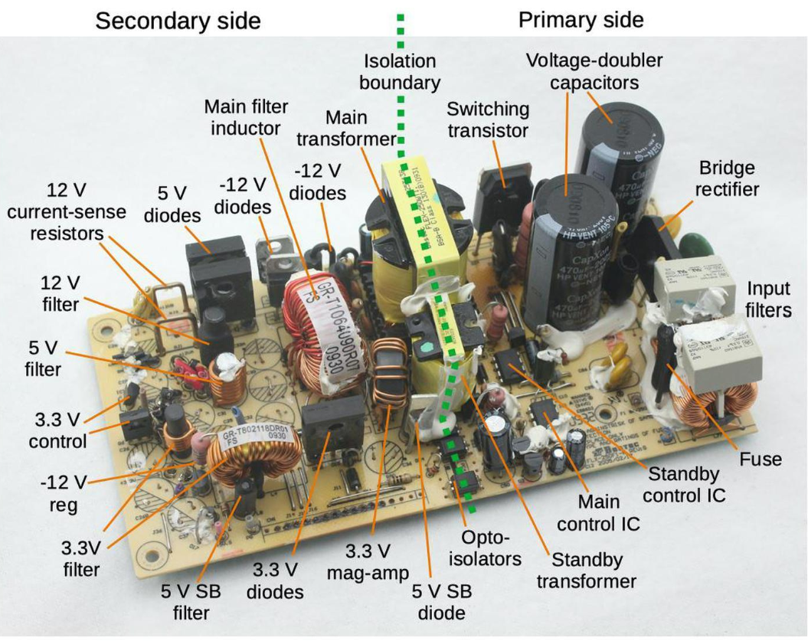

230 V AC Input
↓
EMI Filter & Fuse
↓
Bridge Rectifier — AC → DC
↓
DC Filter / Smoothing Capacitor
↓
Switching Circuit
↓
High-Frequency Transformer
↓
Secondary Rectifier — AC → DC
↓
Output Filter
↓
Regulated DC Output: +12 V, +5 V, +3.3 V
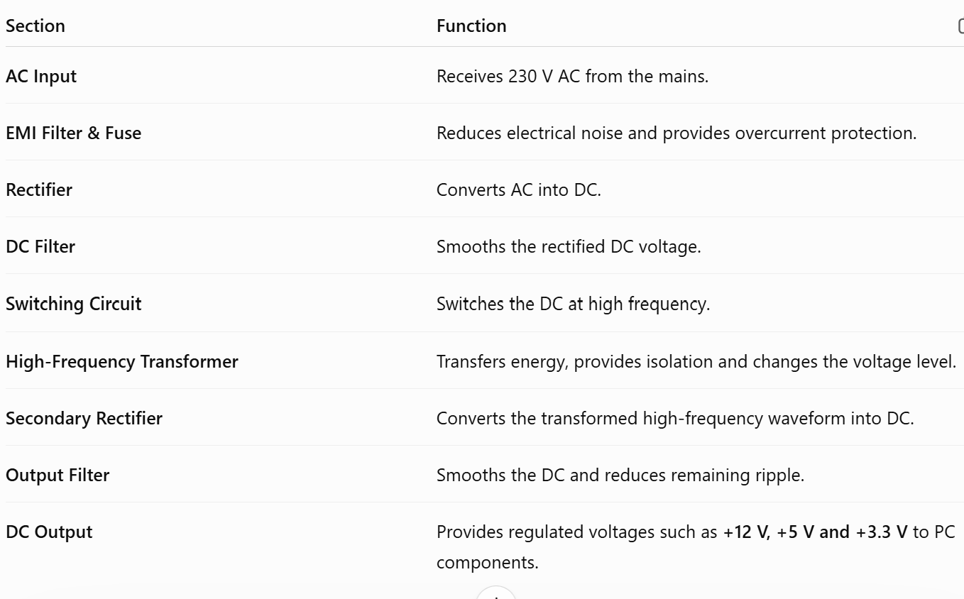

3.Take photos or find clear images online of the following power connectors: ATX 24-pin motherboard connector, SATA power connector, Molex connector, and PCIe 6/8-pin connector. For each, write its name, the devices it powers, and one safety tip for connecting/disconnecting it.
ATX 24-pin motherboard connector
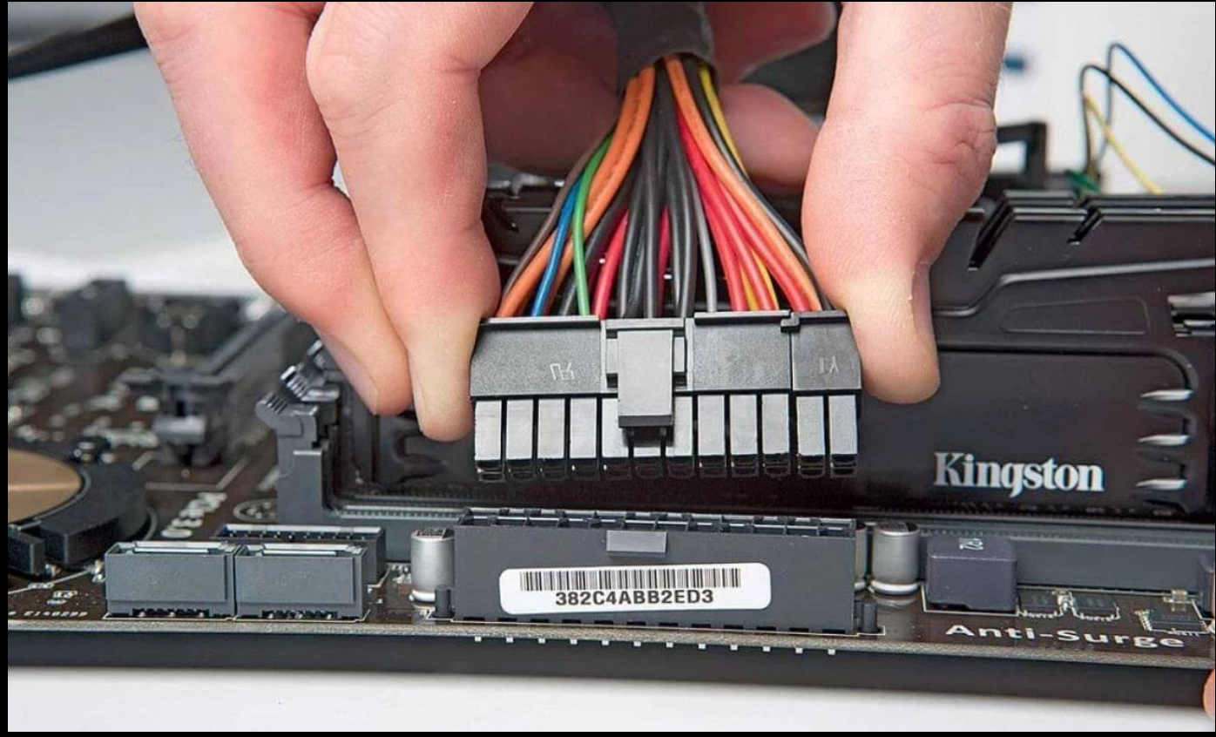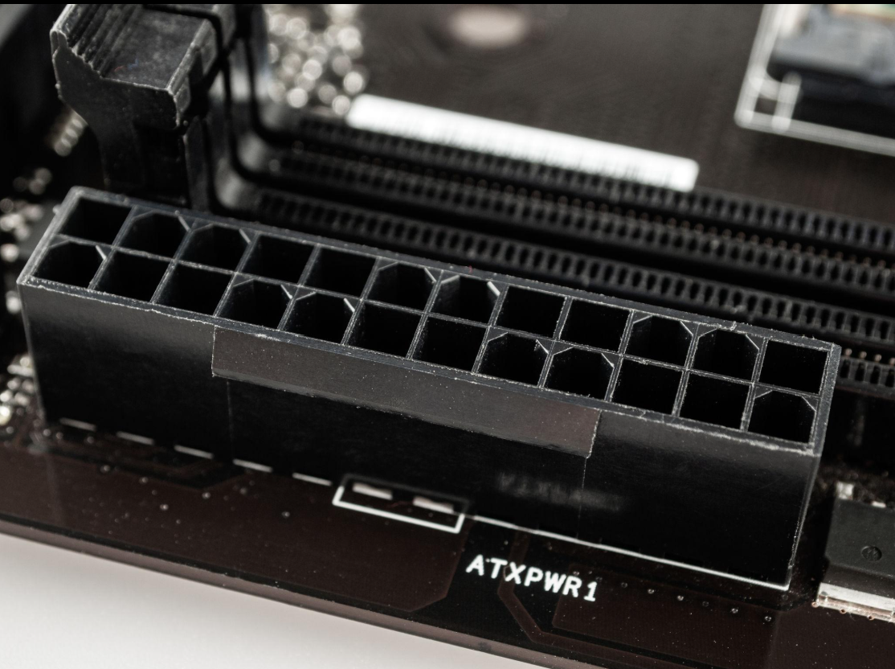
Name: ATX 24-pin motherboard power connector
Pins: 24 pins (often supplied as a 20+4 arrangement)
Connects: PSU/SMPS → Motherboard
Powers: Main motherboard circuits, including power supplied to motherboard components and expansion slots.
How it connects:
The large 24-pin plug from the PSU is inserted into the matching 24-pin ATX socket on the motherboard. The locking clip holds it in place. The connector is keyed so it should fit only in the correct orientation.
Safety tip:
Switch off and unplug the PSU before connecting or disconnecting it. Never force the connector.
2. SATA Power Connector
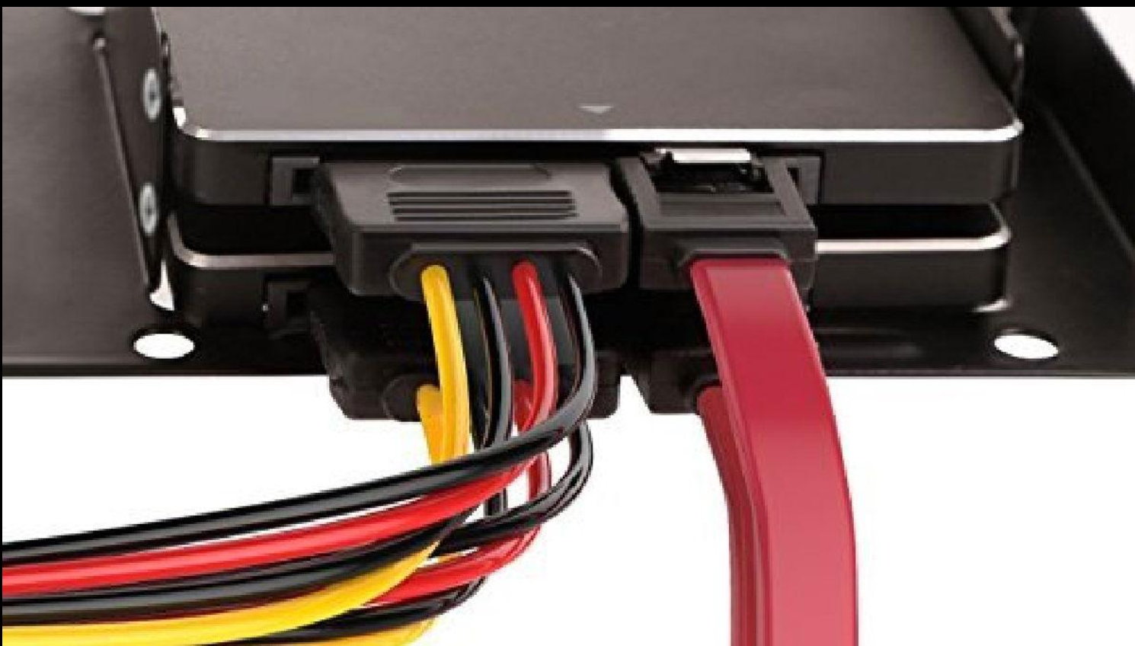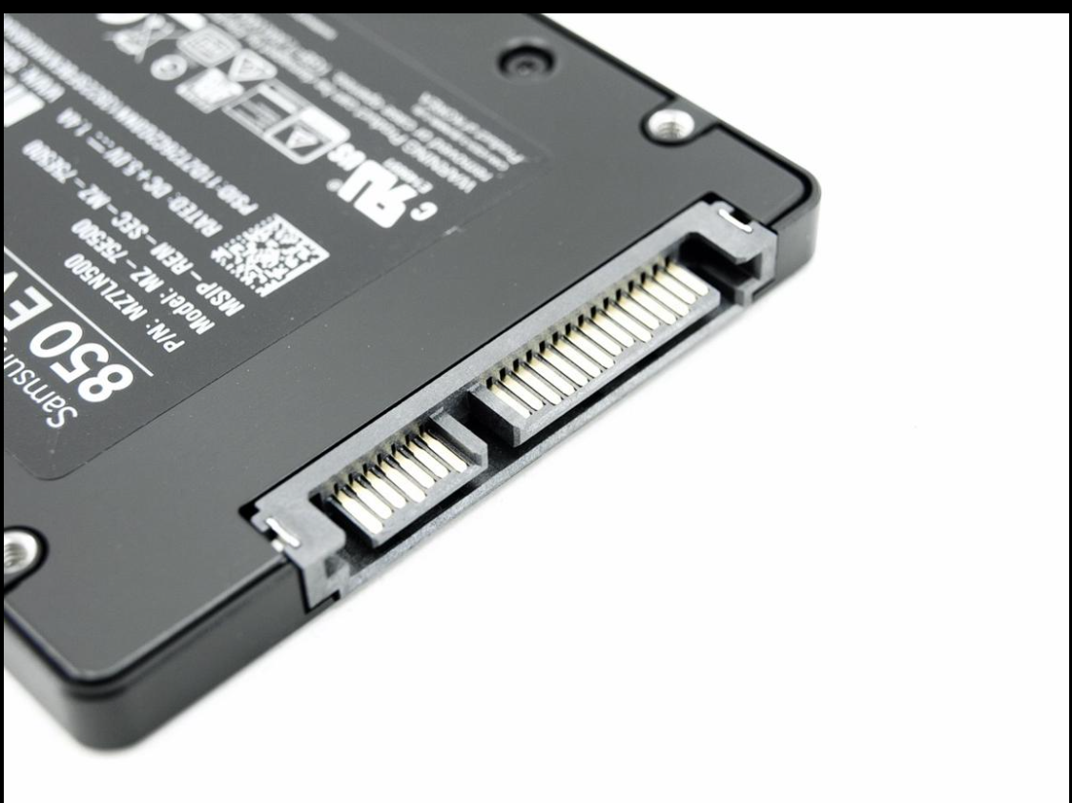
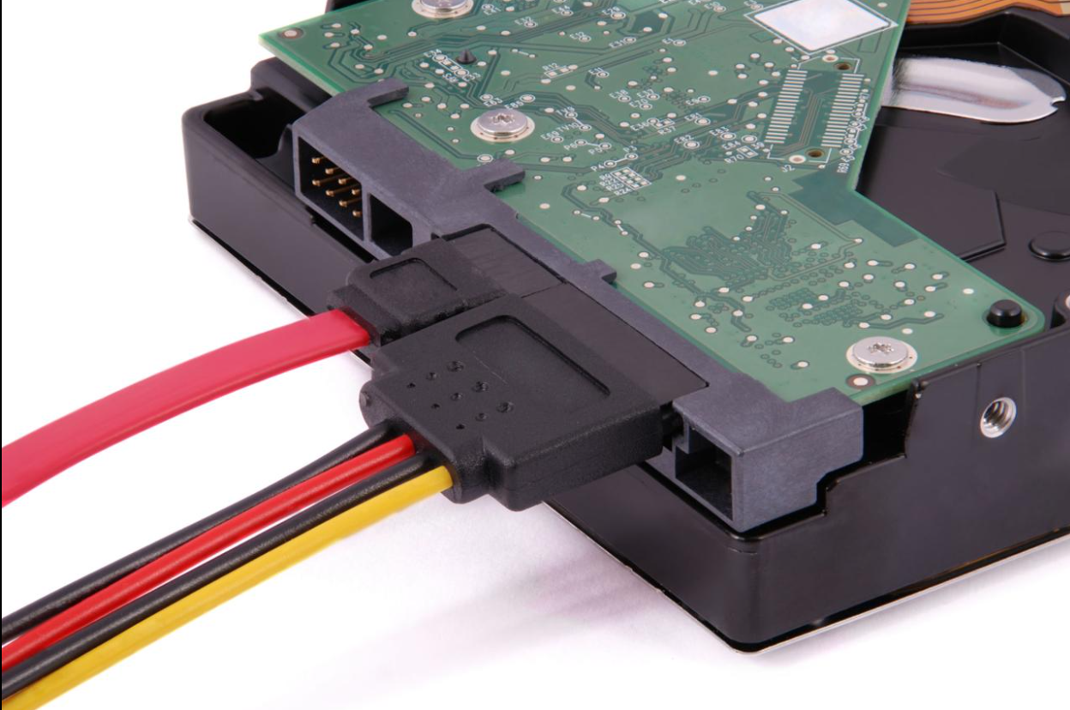
Name: SATA Power Connector
Pins: 15 pins
Connects: PSU/SMPS → SATA HDD/SSD/optical drive
Powers: SATA hard drives, SATA SSDs and SATA optical drives.
The SATA power connector has a characteristic L-shaped key, which helps prevent incorrect insertion. A standard SATA power connector has 15 contacts and provides 3.3 V, 5 V and 12 V power rails.
How it connects:
PSU SATA power plug → SATA power socket on HDD/SSD
Remember:
SATA power cable comes from the PSU.
SATA data cable comes from the motherboard.
Safety tip:
Align the L-shaped key correctly and never force the connector into the drive.

3. 4-Pin Molex Connector
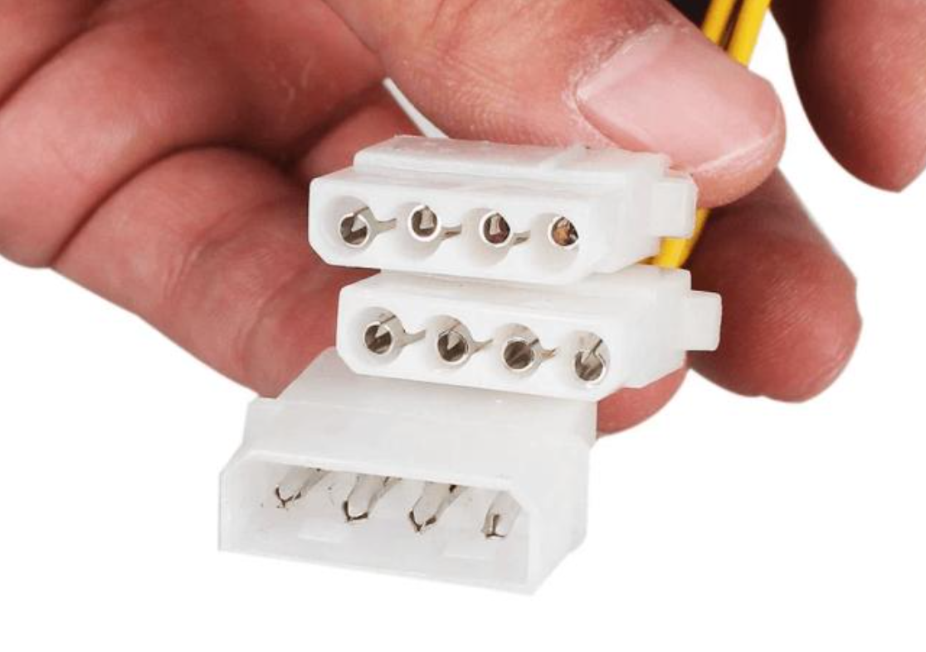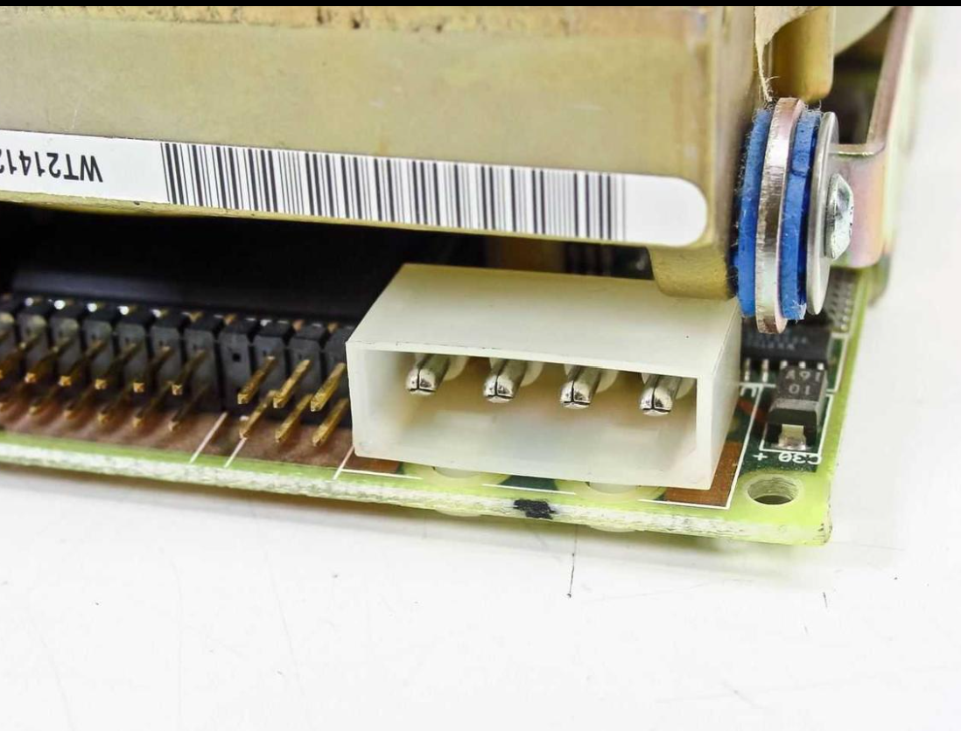
Name: 4-pin Molex peripheral power connector
Pins: 4 pins
Connects: PSU/SMPS → older peripherals/accessories
Powers: Older IDE/PATA drives, some older optical drives, case fans and other peripherals.
The traditional Molex connector has four contacts and was commonly used in older desktop PCs.
How it connects:
PSU Molex plug → Molex socket on peripheral/fan
Safety tip:
Turn off and unplug the computer before connecting or disconnecting the Molex connector, and pull the connector by its plastic body rather than its wires.

PCIe 6/8-Pin Graphics Card Power Connector
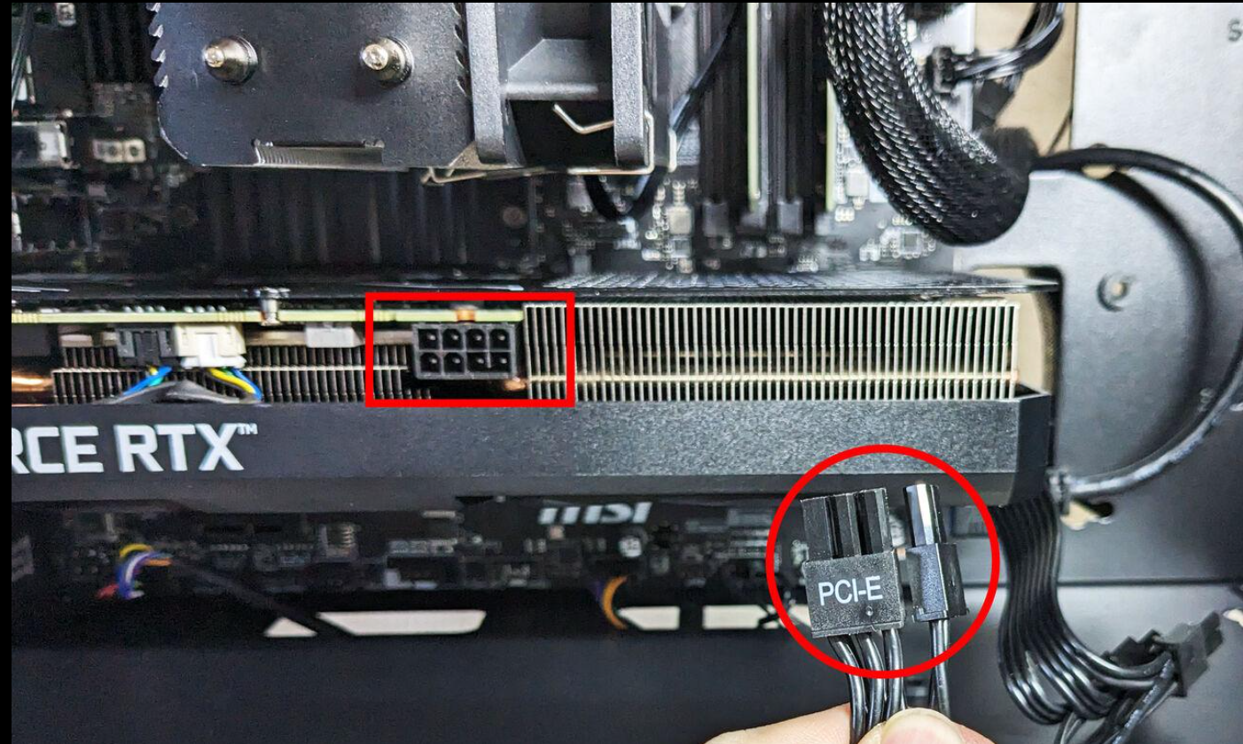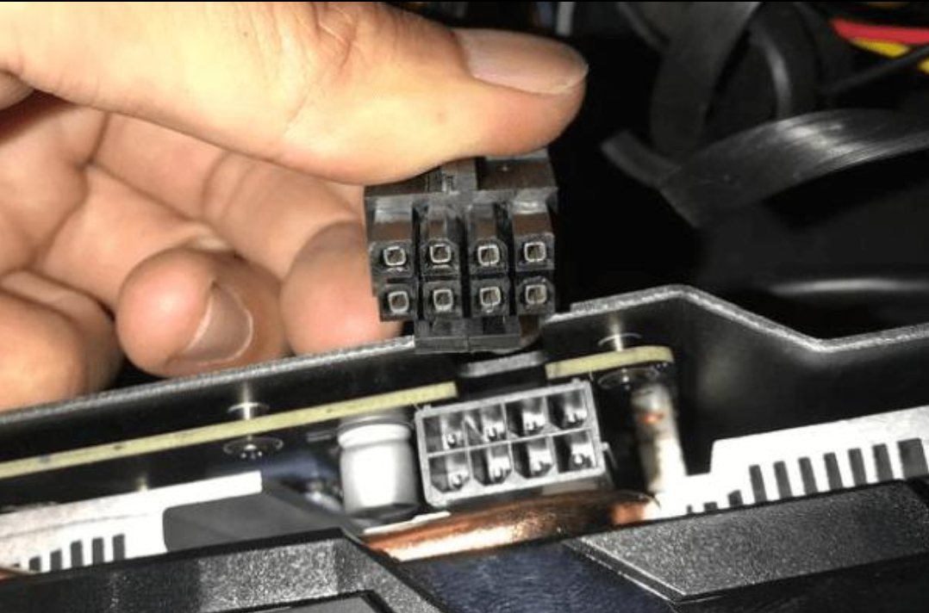
Name: PCIe 6-pin / 8-pin power connector
Pins: 6-pin, 8-pin or commonly 6+2-pin
Connects: PSU/SMPS → Dedicated graphics card
Powers: Provides additional power to a dedicated GPU.
A 6+2-pin PCIe connector can be configured as a 6-pin or 8-pin connection, depending on the graphics card. The connector shown in the example image is inserted into the GPU's PCIe power socket.
How it connects:
PSU PCIe cable → PCIe power socket on graphics card
Safety tip:
Use the PSU cable labelled PCIe/VGA, and do not substitute the CPU/EPS cable, even if the connector appears similar.
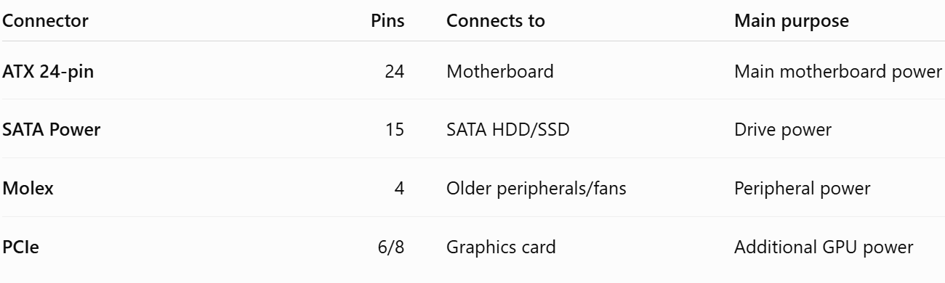

4.Imagine you are setting up a new gaming PC. List the steps you would follow to connect the SMPS to the motherboard, graphics card, and storage devices, mentioning which specific cables and connectors are used for each.
Step-by-step procedure
Step 1 — Turn off the power
Before making any connections:
- Turn the PSU switch to OFF (O).
- Unplug the AC power cable from the wall socket.
- Make sure the PC components are properly installed.
Reason: This reduces the risk of electrical damage while connecting the cables.

Step 2 — Connect the SMPS to the motherboard
The motherboard normally requires two main PSU power connections.
A. 24-pin ATX connector
Take the large 24-pin ATX motherboard cable from the SMPS.
Connection:
SMPS → 24-pin ATX cable → 24-pin socket on motherboard
This is the main power connection for the motherboard.
Make sure the locking clip clicks into place.
B. CPU/EPS connector
Near the CPU socket, the motherboard usually has a 4-pin, 8-pin, or 4+4-pin CPU power socket.
Use the PSU cable labelled CPU/EPS.
Connection:
SMPS → CPU/EPS 4+4 or 8-pin cable → CPU power socket on motherboard
This supplies power to the CPU's voltage-regulation circuitry.
Important: Do not use a PCIe cable in the CPU/EPS socket.

Step 3 — Connect the graphics card
A dedicated gaming GPU may require additional power directly from the PSU.
Depending on the graphics card, it may use:
- 6-pin PCIe
- 8-pin PCIe
- 6+2-pin PCIe
- Or, on some newer high-power GPUs, a newer 12V-2x6/12VHPWR-type connector.
For a traditional 6/8-pin GPU:
SMPS → PCIe/VGA cable → Graphics card
Insert the connector completely until it is properly seated.
Important: Use the cable labelled PCIe/VGA, not the CPU/EPS cable.

Step 4 — Connect a SATA HDD or SATA SSD
If the gaming PC has a 2.5-inch SATA SSD or SATA HDD, it needs a power connection from the SMPS.
Use the SATA power cable.
Connection:
SMPS → SATA power cable → SATA HDD/SSD
The SATA power connector is the wide, flat 15-pin connector.
But there is another cable!
A SATA drive normally needs two separate connections:
1. SATA power:
PSU → Drive
2. SATA data:
Motherboard SATA port → Drive
The SATA data cable does NOT come from the SMPS.
Step 5 — If using an NVMe SSD
If the gaming PC uses an M.2 NVMe SSD, you normally do not connect a separate PSU power cable to it.
The NVMe SSD is installed directly into the M.2 slot on the motherboard.
So:
M.2 NVMe SSD → Motherboard M.2 slot
No separate SATA power cable is required.

Step 6 — Check all connections
Before switching on the PC, check:
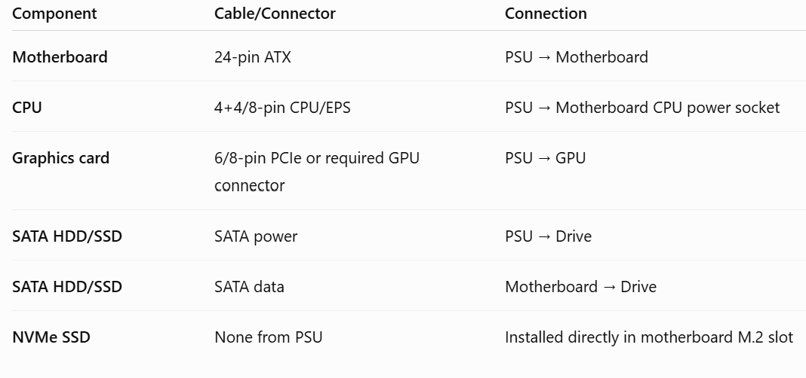
To connect an SMPS in a new gaming PC, first switch off and unplug the power supply. Connect the SMPS's 24-pin ATX cable to the motherboard's 24-pin power socket and connect the CPU/EPS 4+4-pin or 8-pin cable to the CPU power socket. Next, connect the PCIe 6/8-pin or appropriate GPU power cable from the SMPS to the dedicated graphics card. For a SATA HDD or SATA SSD, connect the SATA power cable from the SMPS to the drive and connect a separate SATA data cable from the drive to the motherboard. If an M.2 NVMe SSD is used, it is installed directly into the motherboard's M.2 slot and does not require a separate PSU power cable. Finally, check that all connectors are fully seated and correctly matched before turning on the PC.

